**DAY 4 IMPLEMENTATION REPORT**

### Building Dynamic Frontend Components for Your Marketplace

Creating a successful online marketplace requires a seamless user experience, and dynamic frontend components play a critical role in achieving this. These components provide interactivity, real-time updates, and an intuitive design that enhances user engagement and boosts conversions. Below is an overview of key aspects and best practices for building such components.

**1. Understanding Dynamic Frontend Components**

Dynamic components are user interface (UI) elements that change or update without requiring a full page reload. Examples include:

* **Interactive Filters:** Allow users to refine product searches dynamically.
* **Real-time Notifications:** Inform users of messages, order updates, or offers.
* **Product Carousels:** Highlight featured or recommended items.
* **Live Price Updates:** Reflect pricing changes or discounts in real-time.

**2. Key Technologies and Tools**

To build robust dynamic components, leverage modern frameworks and tools:

* **Frontend Frameworks:** React, Angular, or Vue.js for reusable, state-driven components.
* **State Management:** Tools like Redux or Zustand for handling complex state logic.
* **APIs:** Use RESTful or GraphQL APIs to fetch and update data dynamically.
* **Real-time Features:** Integrate WebSockets or libraries like Socket.IO for instant updates.

**3. Design Principles for Dynamic Components**

* **User-Centric Design:** Prioritize simplicity and ease of use.
* **Performance Optimization:** Minimize load times by lazy loading components and optimizing assets.
* **Responsive Design:** Ensure components adapt seamlessly to different devices and screen sizes.
* **Accessibility:** Follow accessibility guidelines (e.g., WCAG) to make components usable for all.

**4. Challenges and Solutions**

* **Complex State Management:** Use modular approaches to break down state logic.
* **SEO Considerations:** Implement server-side rendering (SSR) for better search engine visibility.
* **Cross-Browser Compatibility:** Test components across multiple browsers and devices.

**5. Example Workflow**

1. **Plan:** Define the component's purpose and user interaction flow.
2. **Design:** Create mockups or wireframes for visualizing the component.
3. **Develop:** Build the component using a framework, connecting it to APIs for dynamic data.
4. **Test:** Perform usability and performance testing on various devices.
5. **Deploy:** Roll out the component incrementally to monitor performance and gather user feedback.

**Conclusion**

Dynamic frontend components are the backbone of a marketplace's interactivity and usability. By combining the right technologies, design principles, and development workflows, you can create components that enhance user satisfaction and drive business growth.

### **Product Listing**

Product listing is a core feature of any marketplace, showcasing items or services in an organized, user-friendly layout. A well-designed product listing allows users to browse, filter, and sort items based on their preferences, such as category, price range, or popularity. Dynamic elements like real-time stock updates, interactive images, and quick preview options enhance the shopping experience. Integrating features like pagination or infinite scrolling ensures scalability, while a responsive design adapts the listings seamlessly across devices. By combining usability, performance, and aesthetics, an effective product listing maximizes engagement and helps users find what they need quickly.

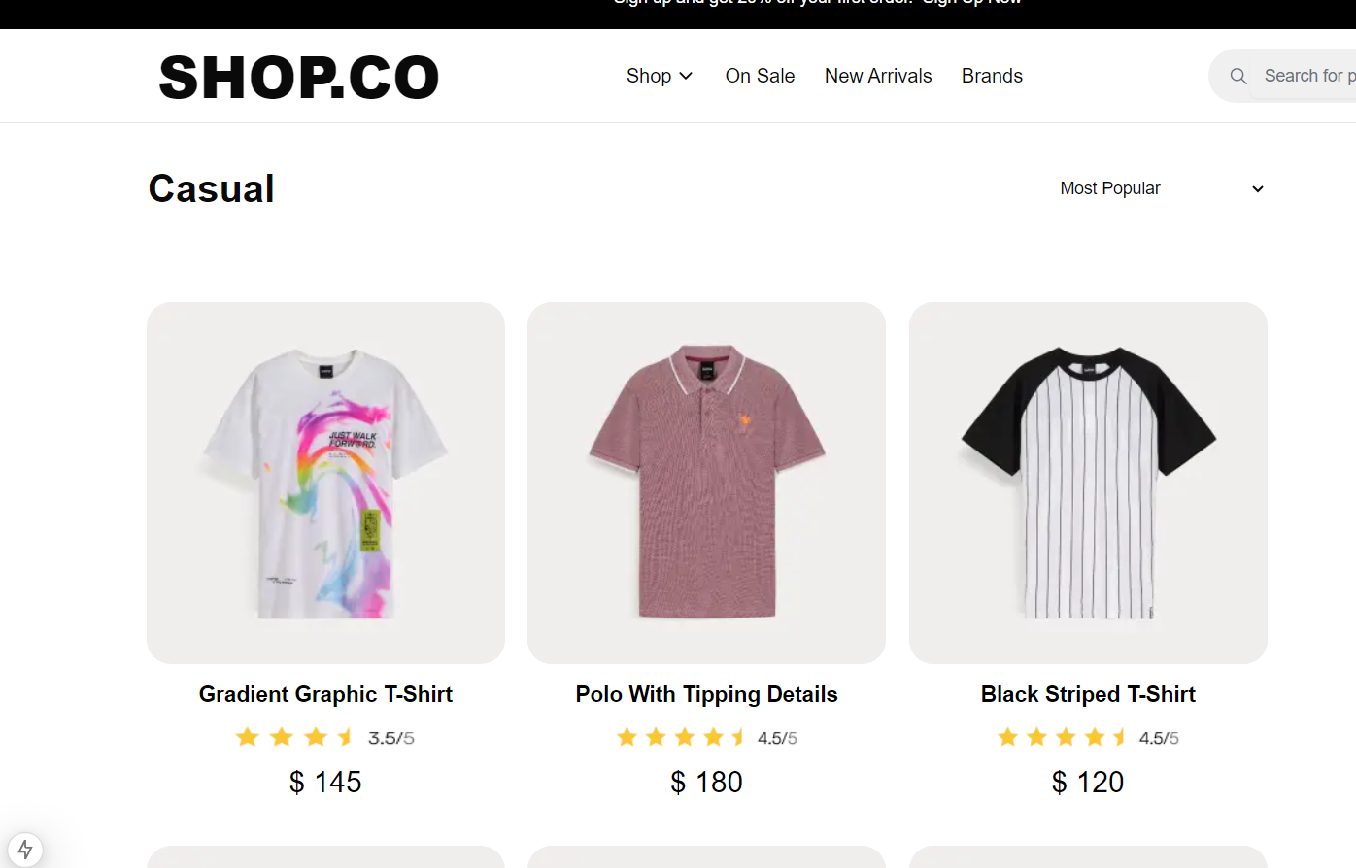

### 

### 

### 

### **Add to Cart Component**

The Add to Cart component is a crucial feature of any marketplace, enabling users to select and save products they intend to purchase. This component should be intuitive and responsive, providing real-time feedback, such as item count updates or confirmation messages, to assure users their actions were successful. Features like quantity adjustment, variant selection (e.g., size or color), and stock availability checks enhance usability. Additionally, integrating a mini cart or cart preview allows users to review their selections without leaving the current page. A well-designed Add to Cart component streamlines the shopping process, encouraging conversions and improving the overall user experience.

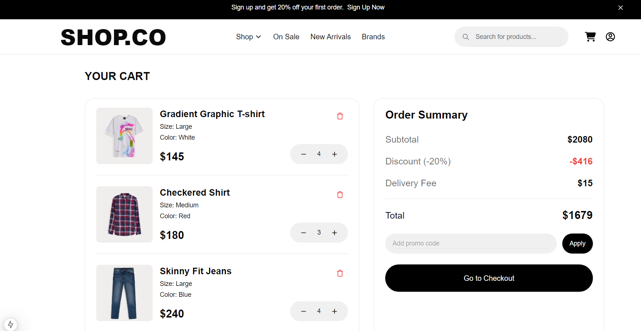

**Checkout Component**

1. **User Authentication:** Ensures users are signed in or provides a guest checkout option for convenience.
2. **Shipping Details:** Collects or confirms delivery address, offering options like address autofill or saved addresses.
3. **Payment Gateway:** Integrates secure payment options, supporting multiple methods like credit/debit cards, wallets, or UPI.
4. **Order Summary:** Displays a detailed breakdown of items, prices, discounts, taxes, and the total amount before confirming the purchase.

### 

### **REVIEW COMPONENTS**

### 

**Star Comment Field:** Provides space for users to share detailed feedback about their experience.

1. **Media Uploads:** Enables users to add images or videos to complement their reviews.
2. **Sorting Options:** Displays reviews dynamically, with filters like most recent, highest-rated, or most helpful.
3. **Community Features:** Includes options to upvote helpful reviews or report inappropriate content.



### **Search Component**

1. **Search Bar:** A prominent input field with placeholder text and optional suggestions or autocomplete functionality.
2. **Filters and Sorting:** Options to narrow down results based on categories, price, ratings, or other attributes.
3. **Instant Results:** Displays relevant matches dynamically as the user types, using predictive search.
4. **Advanced Search:** Allows users to perform detailed queries with multiple criteria for more precise results.
5. **Error Handling:** Provides user-friendly messages for no results or invalid inputs, encouraging further action.

